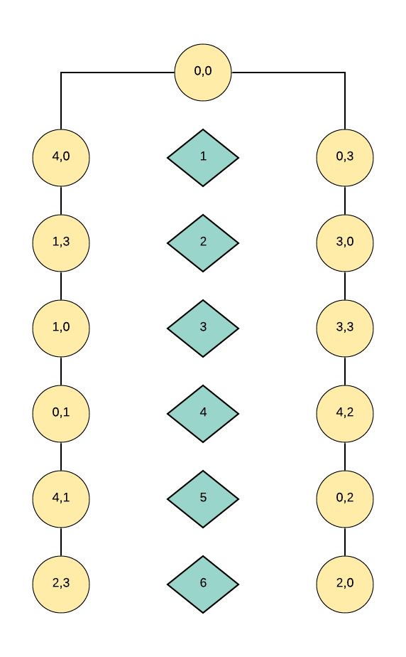

Think 3.1 Given 2 jugs capable of holding 4 and 3 gallons respectively, how do you end up with exactly 2 gallons in the 4-gallon jug?

We can get the answer in two ways.

1. Both jugs are empty. Then in the first step we will fill the jug that capable of holding 4 gallons (jug 4).

In the second step we will pour from 4 gallons to 3 gallons and 1 gallon remains in 4 gallons jugs.

In the third step we will empty the gallon 3.

In the fourth step we will pour one gallon from jug 4 into jug 3.

In the fifth again we will fill jug 4 with 4 gallons of water.

In the sixth step we will fill jug 3 that need 2 gallons to fill.

Therefore, at the end we will have 2 gallons remain in jug 4 and jugs 3 with 3 gallons of water.

1. Both jugs are empty.

In the first step we will fill jug 3.

In the second step we will pour 3 gallons of water from jug 3 to jug 4.

In the third step we will fill jug 3 with 3 gallons of water.

In the fourth step we will fill jug 4 with jug 3 and then it will remain 2 gallons of water in jug 3.

In the fifth step we will empty jug 4.

In the sixth step we will pour 2 gallons of water in jug 3 to the jug 4.

Therefore, at the end we will have 2 gallons of water in jug 4 and no water in jug 3.

(0,0)

(4,0) (4,3) (0,3)

(0,0) (1,3) (4,3) (4,3) (3,0) (0,0)

(1,0) (4,3) (0,3) (0,0) (3,3) (4,0)

(0,0) (0,1) (4,0) (4,3) (4,2) (3,0) (0,3)

(0,0) (4,1) (0,3) (4,3) (0,2) (4,0)

(4,3) (2,3) (4,0) (0,1) (4,2) (0,0) (2,0) (0,3)

(0,0)

(4,0) (0,3)

(1,3) (4,3) (3,0)

(1,0) (3,3)

(0,1) (4,2)

(4,1) (0,2)

(2,3) (2,0)

(0,0)

(4,0) (0,3)

(1,3) (3,0)

(1,0) (4,3) (3,3)

(0,1) (4,2)

(4,1) (0,2)

(2,3) (2,0)